Quantum Optics Lab Operation Software Manual

Ver: 1.0
15.07.2024

Executive Summary
The Quantum Optics Lab Operation Software controls and monitors high-precision hardware devices used in our quantum optics experiments. This manual provides an overview of the software's architecture, hardware integration, and key components for senior and junior developers.
System Architecture: The software's modular architecture includes:
- Main Application: Initializes components and starts the application loop.
- Application Singleton: Manages the application lifecycle and ensures a single instance.
- GUI Overlays: Interfaces for hardware control and monitoring.
- Hardware Wrappers: Hardware-specific details for device communication.
- Device Management: Manages initialization, configuration, and communication with hardware devices.
Hardware Integration: Supported devices include:
- Rohde & Schwarz SGS100A Microwave Source: Controlled via GUI for frequency, power, RF state, and modulation settings.
- SmarAct MCS2 Positioner: Managed through GUI for device selection, position settings, and motion parameters.
- Zelux Camera: Operated via GUI for live capture, exposure adjustments, and image saving.
This manual includes step-by-step usage instructions, and guidance on extending the codebase to integrate new hardware and functionalities. This document aims to ensure smooth operation, facilitate future development, and maintain high coding and documentation standards within the team.

Introduction
The Quantum Optics Lab Operation Software is a sophisticated system designed to streamline the control and monitoring of various high-precision hardware devices used in our quantum optics experiments. This software provides a unified interface for managing microwave sources, positioners, temperature control, and cameras, enabling researchers and engineers to conduct experiments with greater efficiency and precision.
Purpose
The purpose of this documentation is to provide a comprehensive guide to the Quantum Optics Lab Operation Software. It is intended for a diverse audience, including senior developers, and junior developers who will be responsible for maintaining and extending the software. This document aims to:
- Offer an overview of the system architecture and its main components.
- Provide detailed instructions for installation and setup.
- Explain the integration and control of various hardware devices.
- Guide users through the software's functionalities and usage.
- Assist developers in extending the codebase and integrating new hardware.
- Establish best practices for coding and documentation.
Scope
This documentation covers all aspects of the Quantum Optics Lab Operation Software, including:
- System Architecture: An overview of the software's structure and its main components.
- Installation and Setup: Step-by-step instructions for installing and configuring the software.
- Hardware Integration: Detailed descriptions of the hardware devices supported by the software and how they are integrated.
- Software Components: Explanations of the core software modules, including the application singleton, GUI overlays, and hardware wrappers.
- Usage Instructions: Guidance on running the application and using the graphical user interface.
- Error Handling and Debugging: Tips for troubleshooting common issues and debugging the software.
- Extending the Codebase: Instructions for adding new hardware support and modifying existing components.
- Best Practices: Recommendations for maintaining high coding and documentation standards.

Audience
This documentation is intended for:
- CTO: To provide a high-level understanding of the software's capabilities and architecture.
- Senior Developers: To facilitate the maintenance, extension, and integration of new functionalities into the software.
- Junior Developers: To offer a detailed guide for understanding the existing codebase, adding new features, and ensuring consistent development practices.
Objectives
The main objectives of the Quantum Optics Lab Operation Software are to:
- Streamline Hardware Control: Provide a unified interface for controlling various hardware devices used in our quantum optics experiments.
- Enhance Experiment Precision: Enable precise control and monitoring of devices to improve the accuracy and reliability of experimental results.
- Facilitate Development and Maintenance: Offer a well-documented and modular codebase that can be easily extended and maintained by developers of varying experience levels.

Table of Contents
Chapter 1 System Architecture 6
Main Components 6
Data Flow 6
Chapter 2 Scan Process & Instrument Integration 8
Chapter 3 Code Dependencies Analysis 14
Chapter 4 Extending the Codebase 15
Adding New Hardware 15
Adding new experiments 15
Understanding Data Fetching 17
Chapter 5 Writing a New QUA Program: 19
Chapter 6 Installation Process 23
Step-by-Step Installation 23
Introduction to SVN Subversion Control 25
Chapter 7 Usage Instructions 26
Running the Application 26
Using the GUI 26
Chapter 8 Best Practices 28
Coding Best Practices 28
Documentation Best Practices 28
Development Best Practices 29

System Architecture
The Quantum Optics Lab Operation Software is built on a modular architecture designed to provide flexibility, scalability, and ease of maintenance. This chapter outlines the overall architecture, detailing the main components and their interactions.

Main Components

1. Main Application
The main application serves as the entry point for the software. It initializes the necessary components and starts the application loop. The primary functions of the main application are to:
- Initialize the GUI overlays.
- Instantiate the application singleton.
- Start the application run loop.

2. Application Singleton
The Application Singleton manages the application's lifecycle, ensuring that only one instance of the application is running at any given time. Its responsibility is to handle the registration and management of GUI overlays.

3. Graphical User Interface (GUI) Overlays
The GUI overlays provide interactive interfaces for users to control and monitor hardware devices. There are separate GUI modules for each hardware device, such as the Rohde & Schwarz microwave source, SmarAct positioner, and Zelux camera.

4. Hardware Wrappers
Hardware wrappers encapsulate the low-level details of hardware communication, providing a consistent interface for the application to interact with different devices. Each hardware device has its own wrapper class that manages its initialization, configuration, and communication.

5. Device Management
The device management module handles the initialization and configuration of all hardware devices through the HW_devices singleton. It ensures that each device is correctly set up and ready for use by the application.

Data Flow
- User Interaction: Users interact with the GUI overlays to control and monitor hardware devices.
- Command Processing: The GUI overlays send commands to the Hardware Wrappers to perform specific actions on the devices.
- Device Communication: Hardware Wrappers communicate with the physical devices, sending commands and receiving responses.
- Status Update: Hardware Wrappers update the GUI overlays with the current status and data from the devices.
- Application Management: The Application Singleton ensures that all components operate smoothly and manage the overall application lifecycle.

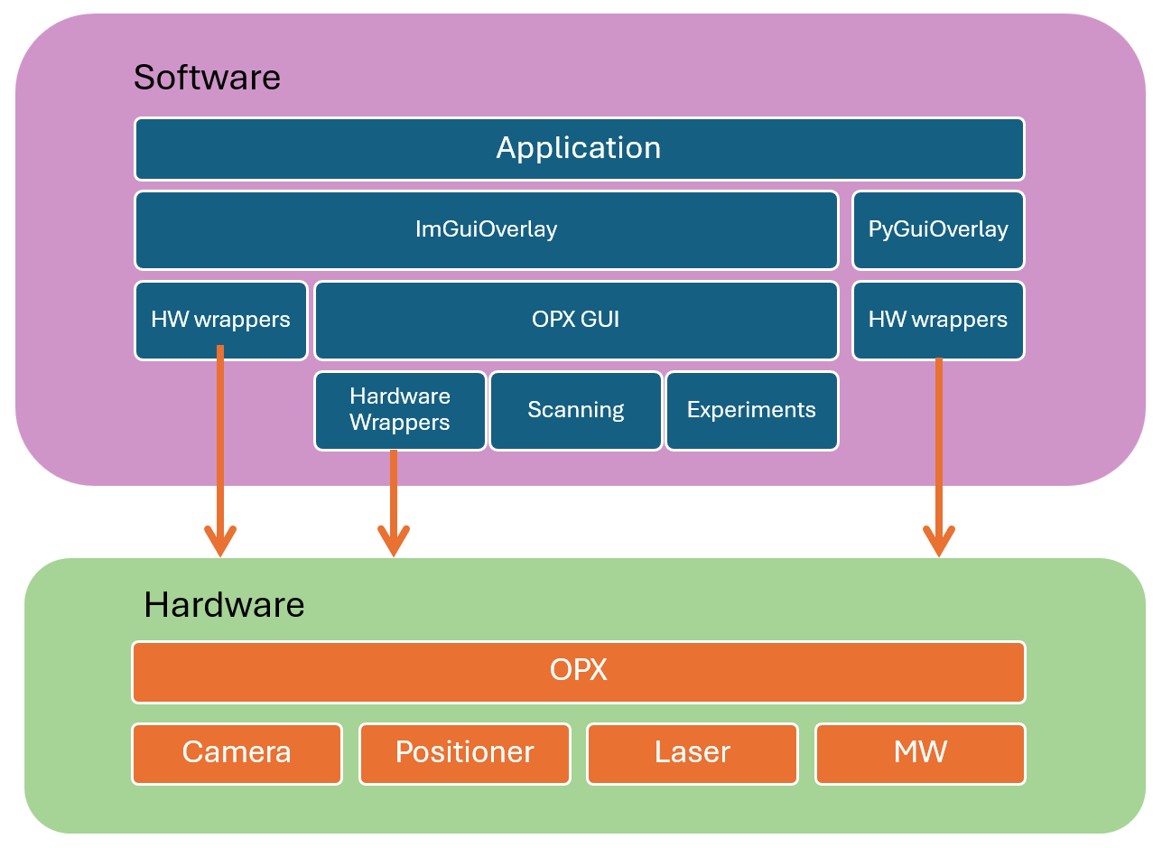

Scan Process & Instrument Integration
Introduction
This chapter delves into the logic, dependencies, functionality, and scan mechanism implemented in the HWrap_OPX.py file, an essential part of the Quantum Optics Lab Operation Software. This file, designed as a workaround for fast integration with the OPX (Quantum Machines' Quantum Orchestration Platform), outlines a sophisticated approach to configuring and managing experiments using the OPX.
Overview
The HWrap_OPX.py script encapsulates the integration logic with the OPX, defining the necessary configurations, pulse sequences, and scan mechanisms. It facilitates the interaction between the main software and the OPX, and various quantum experiments.

Dependencies
The script leverages several dependencies, integrating multiple libraries and modules to achieve its functionality:
- ECM, ImGuiwrappedMethods, Common: Custom modules providing essential functionalities for the software.
- qualang_tools: Quantum Machines python library for controlling the OPX. It includes unit, interrupt_on_close, progress_counter, and fetching_tool for handling units, plotting, and managing experiment progress.
- PyQt5: Employed for GUI elements.
- matplotlib, PIL: Used for plotting and image handling.
- HW_wrapper: Manages hardware device integrations.

OPX & System Configuration
The QuaCFG class is central to configuring the OPX. It initializes various parameters essential for quantum experiments, including frequencies, pulse lengths, and delays. The class also defines methods for creating IQ imbalance matrices and retrieving the configuration dictionary.
Key Attributes
- Frequency Parameters: Defines intermediate and local oscillator frequencies for NV centers.
- Pulse Lengths: Specifies the durations of different pulses used in experiments.
- MW Parameters: Manages microwave amplitude and pulse lengths for NV centers.
- Switch Parameters: Configures delays and buffers for the MW switch.
- Readout Parameters: Sets thresholds for signal detection.
- Delays: Defines various delays in the system to synchronize operations.
Methods
- IQ_imbalance(g, phi): Generates a correction matrix for mixer imbalances due to gain and phase discrepancies.
- GetConfig(): Returns the complete configuration dictionary for the OPX, detailing controllers, elements, pulses, waveforms, and mixers.
GUI_OPX Class
The GUI_OPX class handles the graphical interface and control logic for interacting with the OPX. It manages parameters, coordinates, and the scanning mechanism for quantum experiments.
Key Attributes
- Scan Parameters: Includes dimensions, steps, and initial positions for scans.
- Tracking Parameters: Manages signal intensity correction and reference signal tracking.
- Hardware Interfaces: Integrates microwave modules and positioners through the HW_devices instance.
- Quantum Machine Manager: Manages connections to the OPX.
Methods
- Calc_estimatedScanTime(): Calculates the estimated time required for a scan based on the provided parameters.
- Callbacks: Defines various callback functions to update experimental parameters from the GUI.
- GUI Controls: Manages the GUI elements for controlling integration times, frequencies, power, and other experimental parameters.

Integration with Hardware Devices
The GetConfig function in the QuaCFG class orchestrates the setup of a complex quantum experiment by creating a detailed configuration dictionary that the Quantum Machines' OPX uses to control various hardware devices. This configuration encompasses controllers, elements, pulses, waveforms, and mixers, each with specific roles and interactions. Here's a detailed explanation of how these different parts interact and serve each other within the GetConfig function:
Controllers
The configuration begins by defining controllers, which act as interfaces between the software and the hardware. In this case, the controller "con1" of type "opx1" is specified. The controller configuration includes:
- Analog Outputs: These are used to control the voltage levels for various signals (e.g., MW I, MW Q, and RF). Each analog output is specified with attributes such as offset (initial voltage level), delay (temporal adjustments), and shareable (indicating whether the channel can be used by multiple components).
- Digital Outputs: These control the state of digital devices such as lasers and microwave switches. Each digital output is defined with the shareable attribute to ensure proper signal routing.
- Analog Inputs: These are used for signal detection and measurement, defined with attributes such as offset and gain to ensure accurate data acquisition.
- Digital Inputs: These inputs are used for detecting events like rising edges in signals, with attributes specifying polarity and deadtime.
Elements
Elements represent the physical components of the experiment, such as RF and MW channels, lasers, and detectors. Each element is defined with:
- Input and Output Ports: These specify how the element connects to the controller. For instance, an RF element may have a single input port for RF signals.
- Intermediate Frequencies: These are the frequencies at which the signals are processed before being upconverted or downconverted.
- Operations: These define the possible actions that can be performed with the element, such as generating pulses. Each operation is linked to specific waveforms and digital markers.
Interaction:
- RF Element: Connects to an analog output port on the controller for generating RF signals. It has operations like "const" for continuous pulses.
- MW Element: Connects to both I and Q analog output ports, using a local oscillator for generating MW signals. It includes operations like "cw" for continuous waves and "pi" for pi pulses, each mapped to specific waveforms.
- Laser and Detector Elements: These use digital inputs for control and synchronization. The laser element may turn on/off based on digital markers, while the detector element can perform readout operations, synchronized with other components via digital signals.
Pulses
Pulses define the shapes and durations of signals that elements can generate or respond to. Each pulse type, such as constant pulses or specific quantum gate pulses (e.g., pi pulses), is specified with:
- Operation Type: Indicates whether the pulse is for control or measurement.
- Length: The duration of the pulse.
- Waveforms: The shape of the pulse, specified in terms of I/Q components or a single waveform.
Interaction:
- Operations in Elements: Each operation in an element refers to a specific pulse. For instance, the "pi" operation in the MW element uses the "pi_pulse" definition to generate a precise microwave pulse.
- Synchronization: Pulses ensure that the generated signals are synchronized across different elements. For example, the "readout_pulse" in the detector element must be timed correctly with the "laser_ON" pulse to capture the appropriate signal.
Waveforms
Waveforms define the actual shape of the pulses used in the operations. They are categorized into:
- Constant Waveforms: Used for continuous signals.
- Zero Waveforms: Used when no signal is desired.
Interaction:
- Pulses: Each pulse references a specific waveform. For example, the "cw" operation in the MW element might use a constant waveform to produce a continuous signal.
- Elements: Elements utilize these waveforms to generate the desired signals during experiments.
Digital Waveforms
Digital waveforms specify the on/off states of digital signals. These are crucial for controlling digital devices like lasers and microwave switches.
Interaction:
- Pulses: Digital markers within pulses reference these waveforms to control the state of digital devices. For example, the "laser_ON" operation in the laser element uses a digital waveform to turn the laser on and off at precise times.
- Elements: Digital elements like lasers and detectors use these waveforms to perform their operations in sync with the analog signals.
Mixers
Mixers correct for any imbalances in the I and Q channels. The IQ_imbalance function generates a correction matrix to adjust for gain and phase discrepancies.

Positioners
Positioners, such as the SmarAct MCS2, are managed through the HW_devices module. The GUI_OPX class provides control over positioning parameters, allowing users to set positions, configure motion parameters, and initiate movements.
Lasers and Detectors
Lasers and photodetectors are integrated using digital and analog inputs/outputs configured in the QuaCFG class. The script defines the timing and control sequences for these devices, ensuring synchronization with other experimental components.

Scanning Mechanism
The scanning mechanism in HWrap_OPX.py is designed to provide control over quantum experiments. It involves the following key components:
Coordinate Management
The GUI_OPX class handles the management of XYZ parameters for scanning, including dimensions, steps, and initial positions. It calculates the estimated scan time based on these parameters and updates the GUI accordingly.
Timing Controls
The script manages various timing controls, such as integration times, delays, and pulse durations, to ensure accurate synchronization. These parameters are defined in the QuaCFG class and can be adjusted via the GUI.
Data Collection
Data collection is managed through the OPX by defining specific pulses and waveforms. The script interfaces with the OPX to collect data during scans, utilizing the fetching_tool from qualang_tools to manage and process the collected data. Notice: The fetching process is not synchronized to the experiment!
Execution Flow
The execution flow of the HWrap_OPX.py script is as follows:
- Initialization: The GUI_OPX and QuaCFG classes are instantiated, and the necessary hardware interfaces are initialized.
- User Configuration: Users configure the experimental parameters via the GUI, triggering callback functions to update the internal settings.
- Experiment Setup: The QuaCFG class generates the configuration dictionary based on the user settings.
- Scan Execution: Following user input through the GUI command buttons, the GUI_OPX class initiates the scan process, sending the configuration to the OPX and starting the data collection.
- Data Collection and Processing: The OPX executes the experiment, collects data, and returns it to the main software for processing and visualization.
- Real-Time Feedback: The GUI updates with real-time data, allowing users to monitor the experiment's progress and make adjustments as needed.
Experiment Synchronization
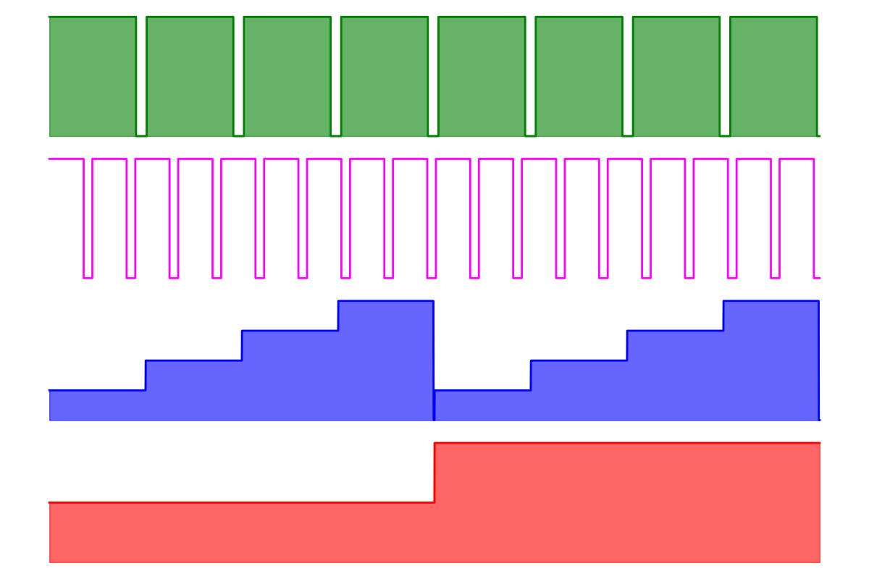
Laser
Stage X
Stage Y
Measurement

Code Dependencies Analysis
The Quantum Optics Lab Operation Software uses various components and libraries to function effectively. The key dependencies and their interactions are as follows:
- Main Application (Main.py)
  - Depends on Application_singletone, PyGuiOverlay, and ImGuiOverlay.
  - Imports various common modules (ECM, Common).
- Application Singleton (Application.py)
  - Manages overlays and application lifecycle.
  - Contains methods to push overlays and run the application.
- GUI Overlays (GUI_RohdeSchwarz.py, GUI_Smaract.py, GUI_Zelux.py)
  - Each overlay depends on specific hardware wrappers.
  - Provides user interfaces to control and monitor devices.
- Hardware Wrappers (Wrapper_RohdeSchwarz.py, Wrapper_Smaract.py, Wrapper_Zelux.py)
  - Encapsulate hardware-specific details.
  - Provide consistent interfaces for interacting with devices.
- Device Management (HW_devices.py)
  - Manages initialization and configuration of hardware devices.
  - Uses singleton pattern to ensure a single instance of each device.
Dependency Graph
Here is a simplified representation of the dependencies:
Main.py
└── Application_singletone
├── ImGuiOverlay (discontinued)
│ ├── GUI_RohdeSchwarz
│ │ └── Wrapper_RohdeSchwarz
│ ├── GUI_Smaract
│ │ └── Wrapper_Smaract
│ └── HWrap_OPX
│ └──GUI_OPX
│ ├── Wrapper_Smaract
│ └── Wrapper_RohdeSchwarz
│
└── PyGuiOverlay
├── GUI_Zelux
│ └── Wrapper_Zelux
└──HWrap_OPX
└──GUI_OPX
├── Wrapper_Smaract
└── Wrapper_RohdeSchwarz

HW_devices.py
├── Wrapper_RohdeSchwarz
├── Wrapper_Smaract
└── Wrapper_Zelux

Extending the Codebase
Extending the Quantum Optics Lab Operation Software involves adding new hardware support, modifying existing components, or enhancing the overall functionality. This chapter provides guidelines for developers to extend the codebase efficiently.

Adding New Hardware
- Create a Hardware Wrapper:
  - Develop a new wrapper class for the hardware device, encapsulating its communication details.
  - Ensure the wrapper provides a consistent interface with methods for initialization, configuration, and control.

- Integrate with Device Management:
  - Create a new field in the HW_devices class to include the new hardware wrapper.
  - Ensure the new device is initialized and accessible through the HW_devices singleton.

- Develop GUI Overlay:
  - Create a new GUI overlay class for the device, providing user interface elements to control and monitor it. Use the GUI elements from the import
import dearpygui.dearpygui as dpg
  - Integrate the overlay into the Application.py , in the PyGuiOverlay class in the on_attach function and execute there the function that creates the GUI controls.

Adding new experiments
This section provides an in-depth explanation of the Experimet class in the HWrap_OPX.py file. It will guide you through its dependencies, functionality, and interactions within the code. By the end of this chapter, you should be able to add new entries to the Experimet Enum and implement them seamlessly.
Overview of the Experimet Class
The Experimet class is an Enum that categorizes different types of quantum experiments. Each enum entry represents a specific experiment or functionality within the quantum system. The Enum helps in managing the flow of execution and ensuring that each experiment type can be identified and executed correctly.
Enum Definition
class Experimet(Enum):
SCRIPT = 0
RABI = 1
ODMR_IQ = 2
ODMR_slow = 3
COUNTER = 4
PULSED_ODMR = 5
NUCLEAR_RABI = 6
NUCLEAR_POL_ESR = 7
NUCLEAR_MR = 8
SANDBOX = 9
Each entry in the Experimet Enum corresponds to a unique experiment setup. For example, RABI is used for Rabi oscillation experiments, while ODMR_IQ is for Optically Detected Magnetic Resonance using IQ modulation.
Initialization and Flow
The flow of execution involving the Experimet class begins with the initialization of the GUI_OPX class, which sets up the necessary configurations and parameters.
The GUI_OPX class initializes self.exp to Experimet.COUNTER as the default experiment
The selected experiment (self.exp) dictates the flow of the program and the specific QUA program to be executed.
Implementing New Experiments
To add a new experiment to the Experimet Enum, follow these steps:
- Add New Entry to Enum: Add the new experiment to the Experimet Enum.
class Experimet(Enum):
SCRIPT = 0
RABI = 1
ODMR_IQ = 2
ODMR_slow = 3
COUNTER = 4
PULSED_ODMR = 5
NUCLEAR_RABI = 6
NUCLEAR_POL_ESR = 7
NUCLEAR_MR = 8
SANDBOX = 9
NEW_EXP = 10

- Initialize the New Experiment: Update the initQUA_gen method in the GUI_OPX class to include the new experiment.
def initQUA_gen(self, n_count = 1):
if self.exp == Experimet.COUNTER:
self.counter_QUA_PGM(n_count=int(n_count))
if self.exp == Experimet.ODMR_slow:
self.counter_QUA_PGM(n_count=int(n_count))
if self.exp == Experimet.ODMR_IQ:
self.odmrIQ_QUA_PGM()
if self.exp == Experimet.RABI:
self.RABI_QUA_PGM()
if self.exp == Experimet.PULSED_ODMR:
self.PulsedODMR_QUA_PGM()
if self.exp == Experimet.NUCLEAR_RABI:
self.NuclearRABI_QUA_PGM()
if self.exp == Experimet.NUCLEAR_POL_ESR:
self.NuclearPolESR_QUA_PGM()
if self.exp == Experimet.NUCLEAR_MR:
self.NuclearMR_QUA_PGM()
if self.exp == Experimet.SANDBOX:
self.Sandbox_QUA_PGM()
if self.exp == Experimet.NEW_EXPERIMENT:
self.NewExperiment_QUA_PGM() # New method call
- Define the QUA Program for the New Experiment: Implement the QUA program method for the new experiment. This method will define the specific operations and logic for the experiment. Read ‎Chapter 5 for more details on how to write in QUA.
- Add a New Button to Execute the Experiment Sequence: The initQUA_gen method in GUI_OPX initializes the appropriate QUA program based on the selected experiment. The QUA program is executed, and the results are streamed back for processing and visualization.
def btnStartNEW_EXP(self):
self.exp = Experimet.NEW_EXPERIMENT
# Hide GUI elements that are not needed for the experiment
self.GUI_ParametersControl(False)
# Set hardware for an experiment.
# The following is an example of a Rabi experiment
self.mwModule.Set_freq(self.mw_freq_resonance) # self.mwFrewRABI)
self.mwModule.Set_power(self.mw_Pwr) # self.mwPowRABI)
self.mwModule.Set_IQ_mode_OFF() # for RABI
self.mwModule.Set_PulseModulation_ON()
self.mwModule.Turn_RF_ON()
self.initQUA_gen(n_count=int(self.total_integration_time * self.u.ms)/int(self.single_integration_time *self.u.us)) # set, load and execute 'counter PGM'
self.StartFetch(_target = self.FetachData)

Understanding Data Fetching
The OPX has a maximum integration window of 500 microseconds. To achieve longer integration times, data must be accumulated over multiple integration windows (bins). This process involves repeatedly measuring the signal and summing the results to reach the desired total integration time. The parameter n_count in the initQUA_gen function corresponds to the number of 500µs bins required for the requested integration time.

Data Fetching Steps
- Setup Integration Parameters: Determine the number of bins needed to reach the total integration time.
- Fetch Data in Bins: Continuously fetch data in 500-microsecond bins.
- Accumulate Data: Sum the data from multiple bins to achieve the total integration time.
- Handle Asynchrony: Ensure robust data processing despite the lack of synchronization between the OPX and the experiment.

Writing a New QUA Program
This chapter provides a detailed manual for writing a new QUA program, NewExperiment_QUA_PGM, based on the example of RABI_QUA_PGM. We will cover the concepts and functions unique to QUA, explaining their purpose and usage. By the end of this chapter, a new developer will be able to confidently implement a new experiment.
Understanding QUA Concepts
QUA (Quantum Universal Assembly) is a domain-specific language designed for quantum control. It includes unique constructs that are not present in standard Python, enabling precise timing, control of quantum operations, and real-time feedback. The code written in the QUA language, although it appears to be a python package, will eventually be compiled in real-time on the FPGA inside the OPX.
Key QUA Concepts and Functions
- declare: Declares variables used in the QUA program.
- for_: Defines a for-loop.
- if_: Defines a conditional statement.
- assign: Assigns values to variables, similar to what a regular “=” operator would do in python.
- measure: Performs a measurement operation.
- play: Plays a pulse sequence.
- wait: Introduces a wait or delay.
- align: Aligns multiple quantum elements in time, enabling synchronization.
- save: Saves data to a stream for later retrieval.
- with stream_processing: Processes and saves streamed data.
Example: RABI_QUA_PGM
The RABI_QUA_PGM method is an example of a QUA program for a Rabi oscillation experiment. It involves scanning a range of pulse durations to observe oscillations in a quantum system.
Detailed Steps for Writing NewExperiment_QUA_PGM
- Define Delays and Time Vectors
Set up the necessary delays and time vectors for the experiment. These are typically in units of clock cycles (4 ns per cycle).
def NewExperiment_QUA_PGM(self):
# Define delays
t_init = self.t_reset // 4 # Initialization delay in cycles
t_refDelay = self.t_ref_delay // 4 # Reference delay in cycles
t_mwDelay = self.t_mw_delay // 4 # Microwave delay in cycles
t_laserDelay = self.t_laser_delay // 4 # Laser delay in cycles

# Define time scan vector

# Minimum time in cycles
tExp_min = self.scan_t_start // 4 if self.scan_t_start // 4 > 0 else 1
# Maximum time in cycles
tExp_max = self.scan_t_end // 4 if self.scan_t_end // 4 > 0 else 1
dt = self.scan_t_dt // 4 # Time step in cycles
# Time vector in ns
self.t_vec = [i * 4 for i in range(tExp_min, tExp_max + 1, dt)]
# Initial time vector in cycles
self.t_vec_ini = np.arange(tExp_min, tExp_max + dt / 10, dt)

- Define indexes vector
# Define indexes vector
array_length = len(self.t_vec)
idx_vec_ini = np.arange(0, array_length, 1)
self.Calc_k_rep(array_length)

- Start QUA program
# Start QUA program
with program() as self.quaPGM:
# QUA program parameters
times = declare(int, size=100)
times_ref = declare(int, size=100)
t = declare(int) # Time variable for scanning
k = declare(int) # Iteration for averaging
n = declare(int) # Outer iteration
n_st = declare_stream() # Stream for iteration number
counts = declare(int, size=array_length) # Signal counts
counts_tmp = declare(int) # Temporary counts
counts_ref = declare(int, size=array_length) # Reference counts
counts_ref_tmp = declare(int) # Temporary reference counts
# Shuffle parameters
# Time vector in QUA
val_vec_qua = declare(int,
value=np.array([int(i) for i in self.t_vec_ini]))
# Index variable for looping
idx_vec_qua = declare(int,
value=idx_vec_ini) # Index vector idx = declare(int)
# Stream parameters
counts_st = declare_stream() # Stream for signal counts
counts_ref_st = declare_stream() # Stream for reference counts
CheckIndexes_st = declare_stream() # Stream for index checks

# Outer loop for averaging
with for_(n, 0, n < self.n_avg, n + 1):
with for_(idx, 0, idx < array_length, idx + 1):
assign(counts_ref[idx], 0)
assign(counts[idx], 0)
with if_(self.bEnableShuffle):
self.QUA_shuffle(idx_vec_qua, array_length)
# Inner loop for averaging
with for_(k, 0, k < 1, k + 1):
with for_(idx, 0, idx < array_length, idx + 1):
# Assign time from shuffled index
assign(t, val_vec_qua[idx_vec_qua[idx]])
# Reset operation
play("Turn_ON", "Laser",
duration=int(t_init * self.K_rep_avg))
wait(t_laserDelay, "Detector_OPD")
measure("readout", "Detector_OPD", None,
time_tagging.digital(times_ref, self.t_readout * self.K_rep_avg * self.ref_readout_factor, counts_ref_tmp))
assign(counts_ref[idx_vec_qua[idx]], counts_ref[idx_vec_qua[idx]] + counts_ref_tmp)
# Main operation
align()
wait(t_mwDelay, "MW")
play("cw", "MW", duration=t)
align()
wait(t_mwDelay)
play("Turn_ON", "Laser", duration=int(t_init))
wait(t_laserDelay, "Detector_OPD")
measure("readout", "Detector_OPD", None, time_tagging.digital(times, self.t_readout, counts_tmp))
assign(counts[idx_vec_qua[idx]], counts[idx_vec_qua[idx]] + counts_tmp)
align()
wait(t_init)
- Save counts to stream
# Save counts to stream
with for_(idx, 0, idx < array_length, idx + 1):
save(counts[idx], counts_st)
save(counts_ref[idx], counts_ref_st)
save(idx_vec_qua[idx], CheckIndexes_st) # For debugging
save(n, n_st)
# Stream processing
with stream_processing():
counts_st.buffer(len(self.t_vec)).average().save("counts")
counts_ref_st.buffer(len(self.t_vec)).average().save("counts_ref")
counts_ref_st.buffer(len(self.t_vec)).save("counts_ref_last")
n_st.save("iteration")
- Execture the QUA program

# Execute QUA program
self.qm = self.qmm.open_qm(self.quaCFG.GetConfig())
self.job = self.qm.execute(self.quaPGM)

Detailed Explanation of New QUA Concepts
- declare: This function is used to declare variables and arrays within a QUA program. The syntax is declare(type, size=None, value=None), where type can be int, fixed, or bool, size defines the array size, and value is the initial value.
- for_: This is the QUA equivalent of a for-loop. The syntax is with for_(var, start, condition, step):, where var is the loop variable, start is the initial value, condition is the loop condition, and step is the increment.
- if_: This is the QUA equivalent of an if-statement. The syntax is with if_(condition):, where condition is the condition to evaluate.
- assign: This function assigns a value to a variable. The syntax is assign(var, value).
- measure: This function performs a measurement operation. The syntax is measure(operation, element, output, integration), where operation is the measurement type, element is the quantum element, output is the storage variable, and integration defines how the measurement is processed.
- play: This function plays a pulse sequence. The syntax is play(operation, element, duration), where operation is the pulse type, element is the quantum element, and duration is the length of the pulse.
- wait: This function introduces a delay. The syntax is wait(cycles, element), where cycles is the number of clock cycles to wait, and element is the quantum element to wait for.
- align: This function aligns multiple quantum elements in time. It ensures that subsequent operations on these elements start simultaneously.
- save: This function saves data to a stream for later retrieval. The syntax is save(var, stream), where var is the variable to save, and stream is the stream identifier.
with stream_processing: This context manager processes and saves streamed data. Inside this block, operations like averaging and saving to storage are defined.

Installation Process
This chapter provides detailed instructions on setting up the Quantum Optics Lab Operation Software on a clean computer. The steps will guide you through installing the necessary software dependencies, setting up a virtual environment, and configuring the codebase for use.
Introduction
The Quantum Optics Lab Operation Software relies on several Python packages and specific hardware drivers. This guide assumes you are starting with a clean computer and will walk you through the process of setting up everything from scratch.
Prerequisites
Before starting the installation process, ensure you have the following:
- Access to the SVN repository located at
Q:\QT-Quantum_Optics_Lab\Lab notebook\SW_Code_Repo
- Administrative privileges on the computer for installing software.

Step-by-Step Installation

1. Install Python
Download and install version 3.11.9 of Python from the official Python website. Ensure you check the option to add Python to your system PATH during installation.

2. Set Up SVN (Subversion)
SVN (Subversion) is a version control system that manages the codebase. You will need to install an SVN client to access the repository.
- Download and install TortoiseSVN from the official TortoiseSVN website.
- Make sure to install the command line tools
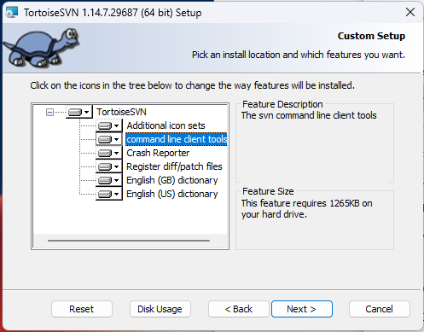

3. Get the Codebase from SVN
- Create a directory C:\WC\HotSystem on your local machine.
- Open Windows Explorer and navigate to C:\WC\HotSystem
- Right-click inside the directory and select "SVN Checkout...".
- In the "URL of repository" field, enter
Q:\QT-Quantum_Optics_Lab\Lab notebook\SW_Code_Repo
- Click "OK" to start the checkout process. This will copy the repository to your local working copy at C:\WC.

4. Set Up the Virtual Environment
- Open the PowerShell window as an administrator.
- Navigate to your working directory:
cd C:\WC\HotSystem
- Create a virtual environment:
python -m venv venv
- Activate the virtual environment:
.\venv\Scripts\Activate.ps1

5. Install SmarAct SDKs
- Install the following executables:
  - Q:\QT-Quantum_Optic_Lab\Lab notebook\Devices\Stages\Smaract\SLC2430\FromUSB\MCS2\MCS2_Installer_2.2.1.exe
  - Choose Python SDK
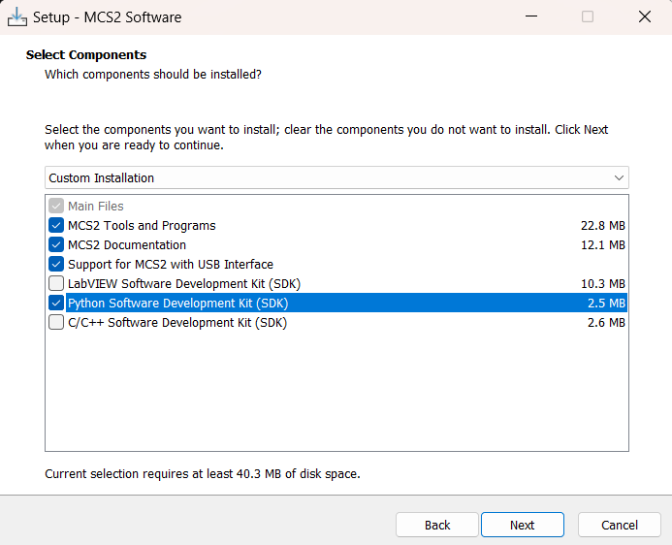
  - Q:\QT-Quantum_Optic_Lab\Lab notebook\Devices\Stages\Smaract\SLC2430\FromUSB\MCS2\MCS2_HSDR_Installer_2.1.5.exe
  - Also here add Python SDK
- Follow the instructions in C:\SmarAct\MCS2\Documentation\Using SmarAct Python SDKs.pdf.

6. Install ThorLabs Zelux SDK
- Install the executable:
  - Q:\QT-Quantum_Optic_Lab\Lab notebook\Devices\2D Camera\ThorLabZelux\Thorlabs Scientific Imaging Software x64.exe
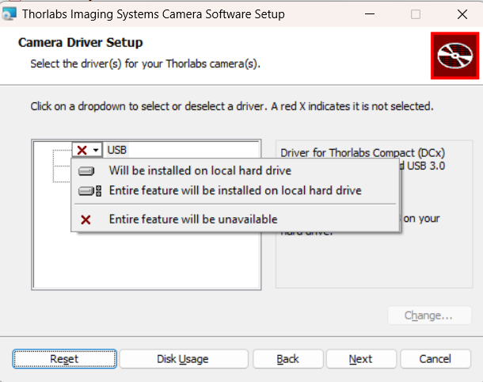

7. Install Swabian SDK
- Install the executables:
  - Q:\QT-Quantum_Optic_Lab\Lab notebook\Devices\nsec IOs controllers\SwabianInstruments\PulseStreamer-1.7.0-32bit.msi
  - Q:\QT-Quantum_Optic_Lab\Lab notebook\Devices\nsec IOs controllers\SwabianInstruments\TimeTagger-2.16.2-64bit.msi

8. Install Python Packages
The necessary Python packages are listed in PackagesList.txt. You can install them manually or use the provided Packages_Install.bat script.
- Using the Batch Script (recommended):
  - Ensure your virtual environment is activated.
  - Run the Packages_Install.bat script
.\Packages_Install.bat

9. Install PyCharm
Go to https://www.jetbrains.com/toolbox-app/ and download the toolbox app. Then, use the tool box app to install PyCharm Professional.
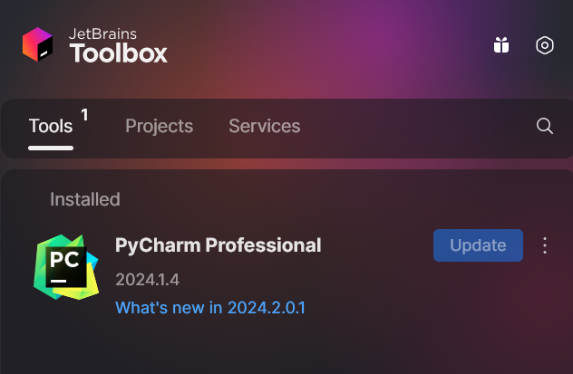
Final Steps
- Ensure all connected hardware devices are powered on and properly connected.
- Verify the installation by running the main application:
python Main.py
- The GUI should open, and you should be able to interact with the hardware devices through the software.

Introduction to SVN Subversion Control
SVN (Subversion) is a version control system that helps manage changes to files and directories over time. It allows multiple developers to collaborate on a project by maintaining a central repository of all versions of the project files.
- Repository: A central storage for all files and their history.
- Working Copy: A local copy of the files from the repository. Changes are made to the working copy and then committed to the repository.
- Commit: The process of sending changes from the working copy to the repository.
- Update: The process of bringing the working copy up-to-date with changes from the repository.
For this project, the repository is located at Q:\QT-Quantum_Optics_Lab\Lab notebook\SW_Code_Repo, and you will use a working copy at C:\WC.
By following these steps, you will have a fully configured environment ready to run the Quantum Optics Lab Operation Software.

Usage Instructions
This chapter provides step-by-step instructions for running the Quantum Optics Lab Operation Software and utilizing its graphical user interface (GUI) to control and monitor various hardware devices.

Running the Application
To run the Quantum Optics Lab Operation Software, follow these steps:
- Ensure Prerequisites are Met:
Install all required software dependencies and hardware drivers according to the instructions in ‎Chapter 6 .Ensure all hardware devices are properly connected and powered on.
- Start the Application:
  - Navigate to the directory containing the software.
  - Run the main script: Main.py
  - The application will initialize and the main GUI window will open.

Using the GUI
The GUI provides an interactive interface for controlling and monitoring hardware devices. Each device has a dedicated GUI overlay with specific controls.

Rohde & Schwarz Microwave Source
- Set Frequency:
  - Enter the desired frequency in GHz.
  - Click the "Set Frequency" button.
- Set Power:
  - Enter the desired power level in dBm.
  - Click the "Set Power" button.
- Toggle RF State:
  - Click the "Turn ON" or "Turn OFF" button to enable or disable the RF output.
- Set Modulation:
  - Choose the desired modulation settings (e.g., pulse modulation, IQ modulation).

SmarAct Positioner
- Select Device:
  - Use the dropdown menu to select the connected SmarAct device.
- Set Position:
  - Enter the desired position for each channel in nanometers.
  - Click the "Set Position" button.
- Control Movement:
  - Use the keyboard buttons to move the positioner to absolute or relative positions. TODO: explain keys
  - Configure motion parameters such as velocity and acceleration.

Zelux Camera
- Start Live Capture:
  - Click the "Start Live" button to begin live video capture.
  - The live video feed will be displayed in the window.
- Stop Live Capture:
  - Click the "Stop Live" button to end the live video capture.
- Adjust Camera Settings:
  - Use the sliders to adjust exposure time and gain.
  - Click the "Save Image" button to capture and save a snapshot.
Exiting the Application
To exit the application, simply close the main GUI window. The application will shut down and all hardware devices will be safely disconnected.

Best Practices
Adhering to best practices ensures that the Quantum Optics Lab Operation Software remains maintainable, scalable, and efficient. This chapter outlines the best practices for coding, documentation, and overall development.

Coding Best Practices
- Consistent Code Style:
  - Follow a consistent coding style, using a style guide such as PEP 8 for Python.
  - Use meaningful variable and function names that clearly describe their purpose.
- Modular Design:
  - Design the code in modular units, ensuring that each module has a single responsibility.
  - Use classes and functions to encapsulate functionality and promote code reuse.
- Error Handling:
  - Implement robust error handling to manage exceptions and provide informative error messages.
  - Use try-except blocks to handle potential errors and ensure the application remains stable.
- Code Comments:
  - Use comments to explain the purpose and logic of the code, especially in complex sections.
  - Keep comments up-to-date with code changes.
- Testing: (hopefully in the future)
  - Write unit tests for critical components to ensure they function correctly.
  - Use automated testing tools to run tests regularly and catch issues early.

Documentation Best Practices
- Comprehensive Documentation:
  - Provide detailed documentation for all components, including classes, functions, and methods.
  - Include usage examples, parameter descriptions, and return values.
- Update Regularly:
  - Keep the documentation up-to-date with code changes.
  - Review and update the documentation regularly to ensure accuracy.
- User Guides:
  - Provide user guides and manuals to help users understand and utilize the software effectively.
  - Include step-by-step instructions, troubleshooting tips, and FAQs.

Development Best Practices
- Version Control:
  - Use version control systems such as Git to manage code changes and maintain a history of modifications.
  - Create branches for new features and bug fixes to isolate changes and facilitate collaboration.
- Code Reviews:
  - Conduct code reviews to ensure code quality and adherence to best practices.
  - Encourage team members to review each other’s code and provide constructive feedback.
- Continuous Integration:
  - Use continuous integration (CI) tools to automate the build and testing process.
  - Ensure that all code changes pass the tests before merging into the main branch.
- Collaboration:
  - Foster a collaborative environment where team members can share knowledge and assist each other.
  - Use communication tools and platforms to facilitate collaboration and project management.
By following these best practices, developers can ensure that the Quantum Optics Lab Operation Software remains reliable, maintainable, and scalable, enabling the team to deliver high-quality software and support ongoing research in quantum optics.

